Affirmation of Holy Baptism
October 25, 2026
Child of God, you have been sealed by the Holy Spirit
and marked with the cross of Christ forever. “
Allison “Alli” Frey
Landon James Garner
Nora Marie Krocak
Elliot Plummer

PRESENTATION

A congregational representative presents those making affirmation.
President: I present Alli Frey, Landon Garner, Nora Krocak, and Elliot Plummer, who desire to make public affirmation of their baptisms.
Pastor: Let us pray. Merciful God, we thank you for these siblings, whom you have made your own by water and the Word in baptism. You have called them to yourself, enlightened them with gifts of your Spirit, and nourished them in the community of faith. Uphold your servants in the gifts and promises of baptism, and unite the hearts of all whom you have brought to new birth. We ask this in the name of Christ.
Congregation: Amen.

PROFESSION OF FAITH

The congregation may stand and join in the responses.

Pastor: I ask you to profess your faith in Christ Jesus, reject sin, and confess the faith of the church. Do you renounce the devil and all the forces that defy God?
Congregation: I renounce them.
Pastor: Do you renounce the powers of this world that rebel against God?
Congregation: I renounce them.
Pastor: Do you renounce the ways of sin that draw you from God?
Congregation: I renounce them.
Pastor: Do you believe in God the Father?
Congregation: I believe in God, the Father almighty, creator of heaven and earth.
Pastor: Do you believe in Jesus Christ, the Son of God?
Congregation: I believe in Jesus Christ, God’s only Son, our Lord, who was conceived by the Holy Spirit, born of the virgin Mary, suffered under Pontius Pilate, was crucified, died, and was buried; he descended to the dead. On the third day he rose again; he ascended into heaven, he is seated at the right hand of the Father, and he will come to judge the living and the dead.
Pastor: Do you believe in God the Holy Spirit?
Congregation: I believe in the Holy Spirit, the holy catholic church, the communion of saints, the forgiveness of sins, the resurrection of the body, and the life everlasting.

The congregation may be seated.

AFFIRMATION IN THE PRESENCE
OF THE ASSEMBLY

The minister addresses the confirmands.

Pastor: You have made public profession of your faith. Do you intend to continue in the covenant God made with you in holy baptism: to live among God’s faithful people, to hear the word of God and share in the Lord’s supper, to proclaim the good news of God in Christ through word and deed, to serve all people, following the example of Jesus, and to strive for justice and peace in all the earth?
Confirmands: We do, and we ask God to help and guide us.
The minister addresses the congregation.

Pastor: People of God, do you promise to support these siblings and pray for them in their life in Christ?
Congregation: We do, and we ask God to help and guide us.
Pastor: Let us pray. We give you thanks, O God, that through water and the Holy Spirit you give us new birth, cleanse us from sin, and raise us to eternal life.
Congregation: Amen.
Each confirmand comes forward when their name is called.

Pastor: Stir up in ___________ the gift of your Holy Spirit: the spirit of wisdom and understanding, the spirit of counsel and might, the spirit of knowledge and awe of the Lord, the spirit of joy in your presence, both now and forever. Amen.

GIVING OF THE LIGHT

Those making public affirmation stand and face the assembly.

One by one, confirmands light their baptismal candles and then the confirmation candles they’ve made, which depict images of significance in their lives, both inside and outside the church.

Pastor: When you were baptized, your parents or sponsors held a candle for you and spoke the words of Jesus to you. Now today, you hold that candle, and the congregation speaks the words of Jesus to you:
Congregation: Let your light so shine before others that they may see your good works and glorify your God in heaven.
President: Let us rejoice with these Confirmands!
Congregation: Through baptism, God made you members of the priesthood we all share in Christ Jesus. We are fellow members of the body of Christ, children of the Creator, and workers together in the kingdom of God. We rejoice with you in the life of baptism! Together we will give thanks and praise to God and proclaim the good news to all the world.

A BLESSING FOR THE BAPTIZED

This is a blessing
that remembers your baptism
and tells the story
even if your memory cannot.

It watched a community
gather around you.
It heard water poured
and felt the love expand.

This blessing will travel
every distance with assurance
that baptism’s promise
does not wear thin over time.

The gift is hardy and sure.
You could not break it if you tried.
Life has a firm grip on you,
Beloved One.

It is more than enough.
And so are you.

from “Speak it Plain: Words for Worship and Life Together” by Meta Herrick Carlson

Congratulations to the Confirmands of 2026!

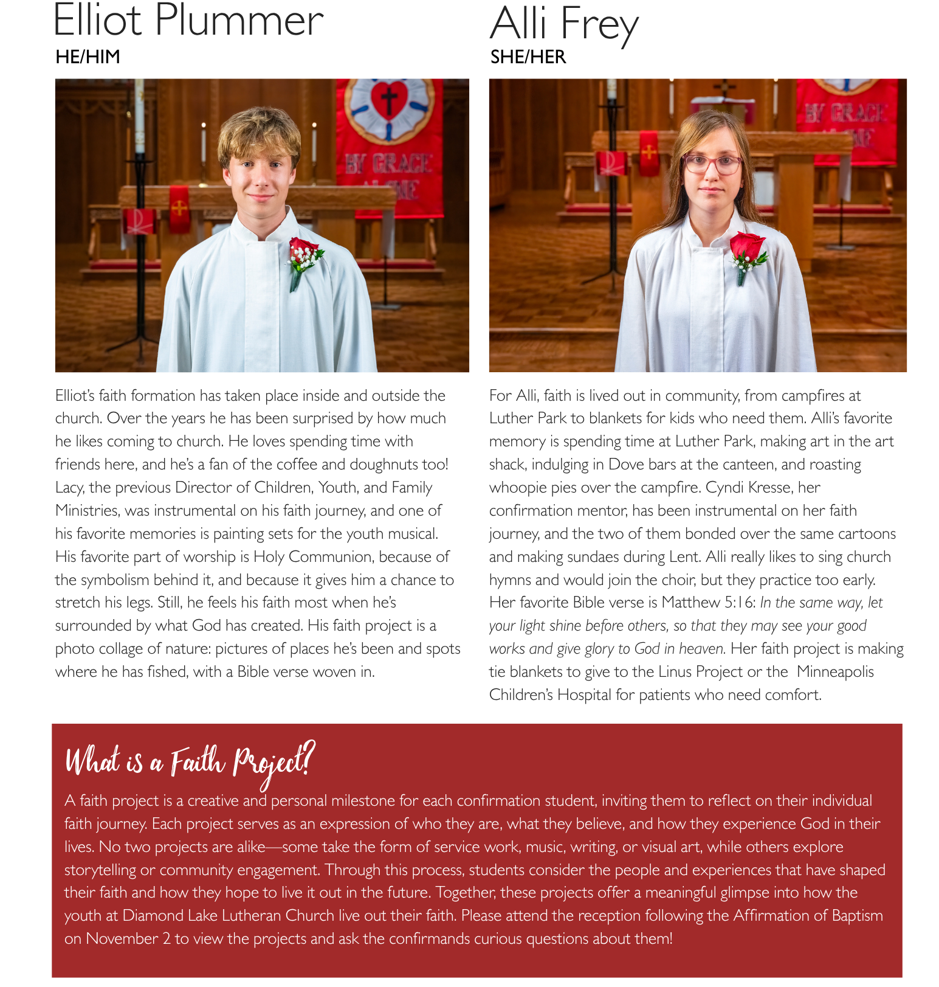

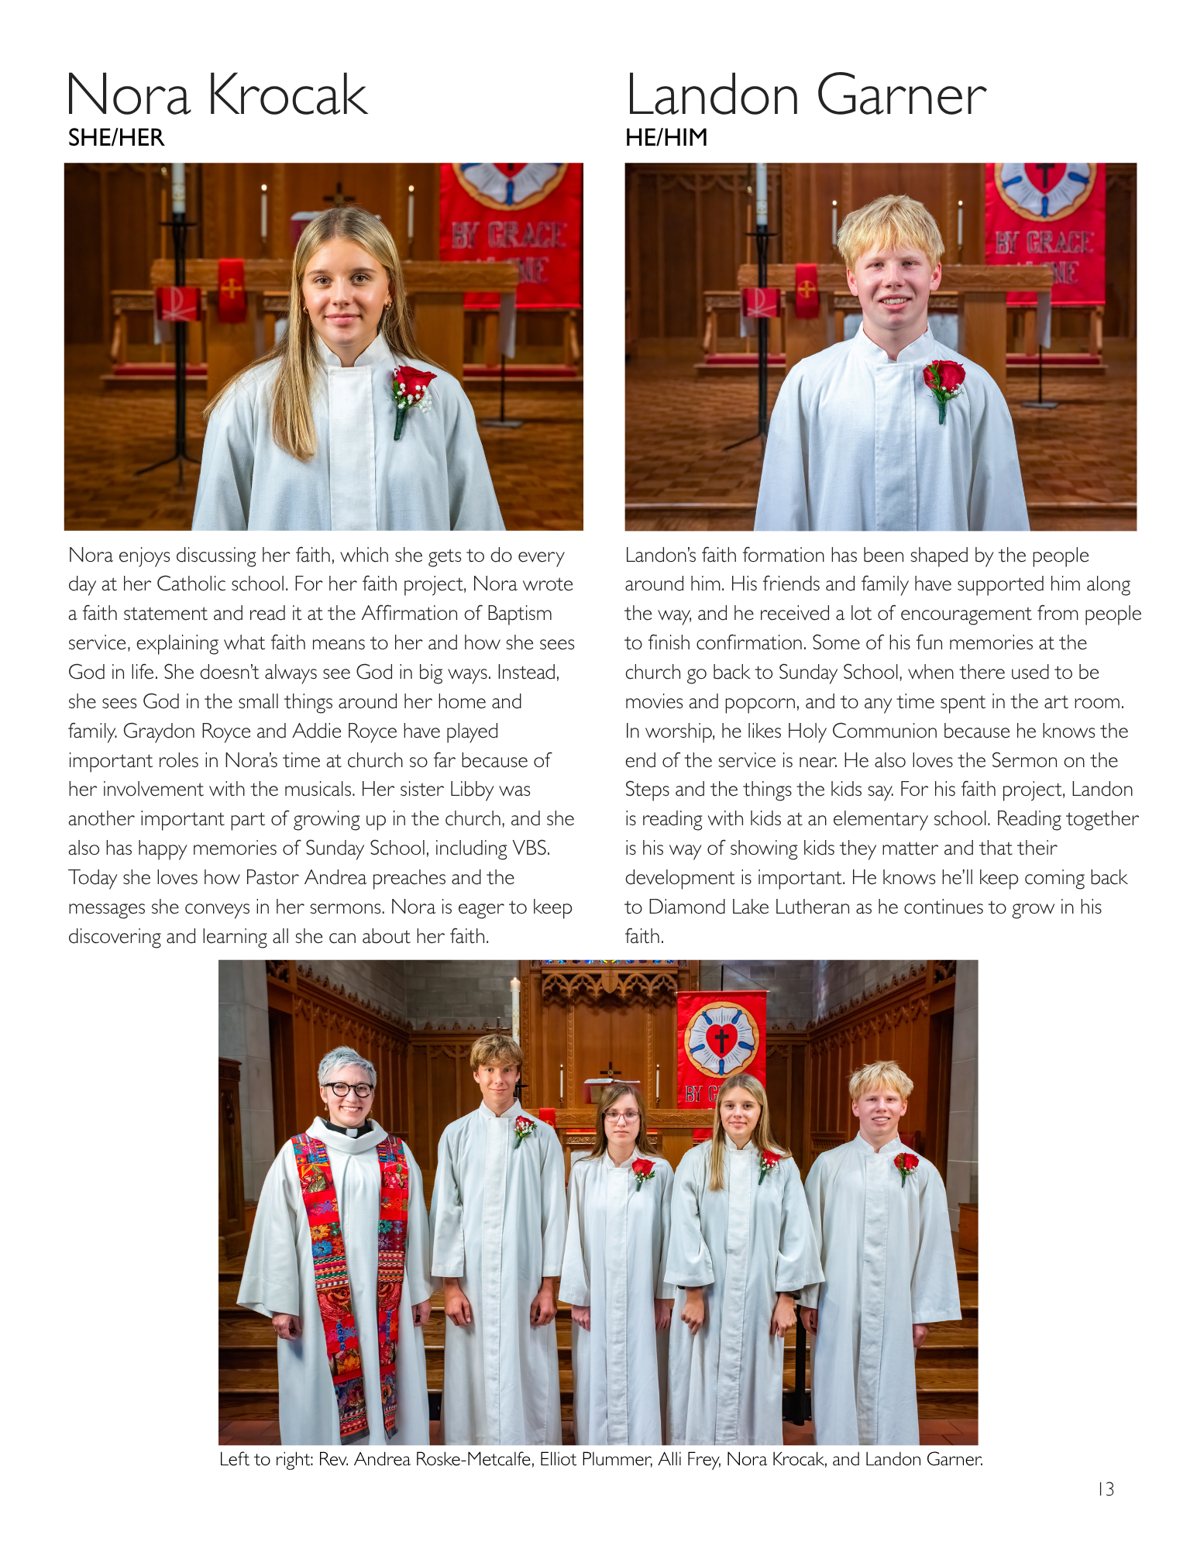

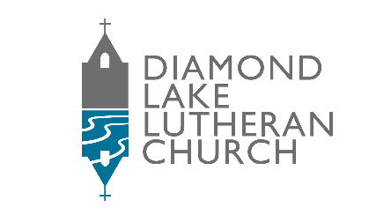

5760 Portland Ave. S., Minneapolis, MN 55417 • 612-866-2579 • www.dllc.org

