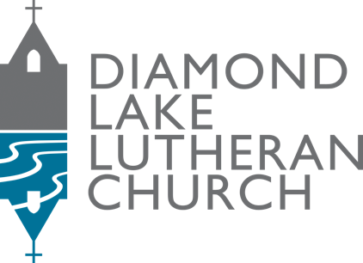

Parish Nurse
Diamond Lake Lutheran Church – 5760 Portland Ave. S, Minneapolis, MN 55417

Reports to: Pastor
Status: Part-time (15 hours/week)
FLSA: Non-exempt
Job Summary
The Parish Nurse will facilitate delivery of holistic health care, evidence-based health and wellness education, and intergenerational health advocacy to the members of Diamond Lake Lutheran Church. Additionally, the Parish Nurse will collaborate with clergy and qualified volunteers to support members and families encountering challenging life events, embracing the congregation’s mission to serve those in need.

Essential Duties:
- Provide pastoral care and visitation to members of the congregation, especially those who are sick, homebound, in crisis, or in situations of grief and loss, in collaboration with the pastor and lay volunteers.
- Serve as staff liaison to the Congregational Care Committee, equipping lay members to care for the congregation and wider community.
- Keep a current network of holistic wellness-related community resources and healthcare services.
- Help facilitate connections to such resources for community members, according to their needs.
- Promote holistic wellness through individual and group education.
- Integrate faith with healing by helping community members to understand the value of spiritual practice in connection with quality of life.
- Develop and make use of data collection and documentation tools to ensure continuity of care practices.

Other Responsibilities:
- Participate in weekly staff meetings and monthly meetings of the Congregational Care Committee. Be present on Sunday mornings, Wednesday mornings, and Wednesday evenings a minimum of twice per month.
- Coordinate checks and updates of emergency health equipment (AED, first aid kits, etc.)
- Coordinate and network with community health education providers

Minimum Qualifications:
- Registered Nurse currently licensed in Minnesota
- Baccalaureate prepared Nurse (BAN or BSN) preferred; completion of Parish Nurse/Faith Community Foundations Course within 6 months of hire required
- Minimum of 5 years clinical nursing practice (Medical/Surgical, Home Health Care, Long-term Care, or Community/Public Health Nursing)
- Excellent communication skills, including ability to communicate effectively with staff and members via a variety of platforms (phone, text, email, writing)
- Demonstrated ability to communicate effectively and compassionately with people of diverse backgrounds and circumstances
- Experience working with/for a church or non-profit preferred
- Access to personal vehicle with current driver’s license; must pass MN background check

Physical Requirements: Able to move freely in and out of different care settings (church building, hospitals/clinics/rehab centers, private homes), able to drive, able to use technology for communication purposes.

About Diamond Lake Lutheran Church
Diamond Lake Lutheran is a vibrant, progressive, multigenerational congregation of the ELCA (Evangelical Lutheran Church in America) located in the Diamond Lake neighborhood of south Minneapolis. The congregation is one focused on justice and joy, in relationship and connection to the wider community. Learn more at www.dllc.org.

Compensation Details
- Annual salary of $23,400 ($30/hour) for 15 hours/week, with a potential increase to 20 hours/week in the first few years
- 4 weeks paid vacation, plus paid sick time
- Continuing Education budget

Core Competencies:
- Compassion & Care – Possess a natural sense of care for the well-being of others, communicate a sense of support, demonstrate appropriate and boundaried expressions of care
- Ethics, Integrity, Trust – Practice direct, transparent communication, honor confidentiality (in accordance with HIPPA and other applicable privacy laws or regulations), respond to situations with constancy and reliability
- Listening – engage in attentive listening for things spoken beneath the surface, desire to genuinely hear the concerns of others
- Non-Anxious Presence – Remain calm and collected in the face of crisis situations

Interested parties should submit a resume and letter of interest to Pastor Andrea Roske-Metcalfe at andrea.roske-metcalfe@dllc.org. Resumes will be received and interviews conducted on a rolling basis until the position is filled.

